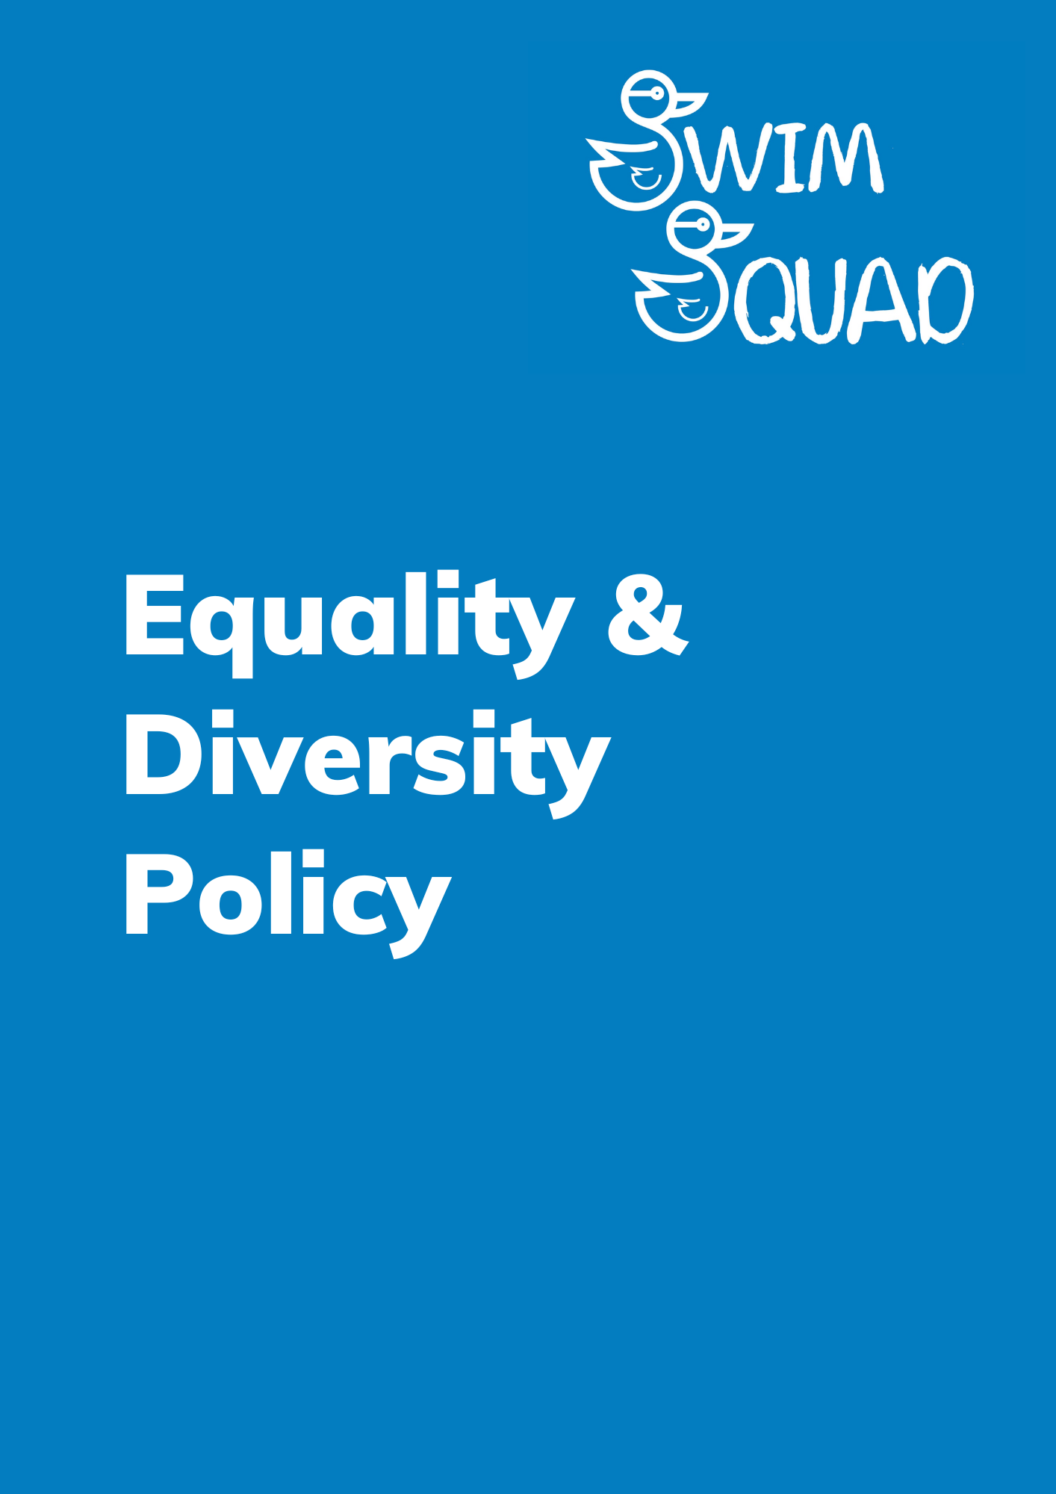
Purpose
Swim Squad is committed to ensuring equal opportunities for all. We believe that all members have the right to be treated with dignity and respect, regardless of their age, disability, gender reassignment, marriage and civil partnership, pregnancy and maternity, race, ethnicity, religion or belief, sex, and sexual orientation. We will not tolerate unfair treatment or unlawful discrimination, whether intentional or unintentional, direct, or indirect. Swim Squad will ensure that equity is incorporated in all aspects of its activities. All who represent Swim Squad are responsible for implementation of this policy.

Policy
Swim Squad is committed to The Equality Act 2010 by taking positive action to:
- Comply with current legislative requirements and ensure this is adhered to
- Develop services which take into consideration the needs of all members and do not unnecessarily discriminate against any individual or group.
- Promote fair access to services, minimising any barriers to access.
- Ensure content and language of all written content is non-discriminatory and free from any bias or stereotypical wording.
- Monitor entry requirements to identify barriers to access and remove or minimise unnecessary barriers or bias which could impact on individuals or groups.

Swim Squad shall implement this policy through:
- Ensuring staff and members have access to this information to assist them in planning, putting into practice and monitoring their rights and responsibilities under this policy.
- Providing support and relevant training/updates for all staff and members and revising any policy or practice that could disadvantage individuals or groups.
- Provision of regular CPD/updates for staff and members
- Ensure all staff and members know how to offer feedback and register complaints.
- Effective complaints procedures will be used to resolve complaints of discrimination with full and prompt consideration under this policy.
- Breaches of this policy will be dealt with through Swim Squads complaints policy.

Swim Squad recognises the need to acknowledge the diversity of provision that is required to ensure that all people, regardless of their race, sex/gender, disability, age, sexual orientation, social or economic background can access swimming and develop at a level that is appropriate to them.
Swim Squad recognises the need to celebrate differences and diversity of provision as a means of creating entitlement and accessibility to our structures.
Swim Squad recognises that equal opportunity is about recognising that people are different and therefore require different provision.
Swim Squad recognises the need to consult widely to respond to diversity addressing Equal Opportunities.
In addressing equal opportunities, Swim Squad will respond to issues of equality by:
• Recognising that swimming as an organisation requires our staff and teachers to adapt and work flexibly to respond to the needs of a wide and diverse range of people.
• Take positive action to increase the involvement from underrepresented groups in all aspects of our organisation, participation, coaching, teaching, etc.

In doing so, Swim Squad supports four key principles as being fundamental to ensuring that everyone can participate in our sport and the achievement of equality of opportunity:
1. Entitlement: People have a right to participate in and access quality and appropriate experiences within swimming.
2. Accessibility: It is the responsibility of Swim Squad to provide a service and where possible will make every allowance to accommodate the needs of each individual.
3. Inclusion: Wherever and whenever possible, all swimmers to access the same quality of provision, and if necessary to use positive action to ensure this.
4. Integrity: As a provider, Swim Squad, aim to change or adapt provision, to ensure lessons are challenging, relevant and in no way patronising.

Swim Squad, as an employer, aspires to provide a diverse workforce, a composition of which reflects that of the broader community in terms of gender, ethnicity, and disability.
In order to bring about this diversity we undertake to:
• Provide full and fair considerations for all job, role and applications.
• Assist all our employees to realise their full potential by ensuring that they receive fair consideration of their training and career development needs and promotion opportunities.
• Maintain full records in recruitment, training and employment and use this information as a means of identifying areas of inequality.
• Require all our employees to undergo relevant training before taking part in recruitment and selection.
• Regularly review our recruitment, selection, training, and promotion procedures to ensure that they are fair and reflect current best practice.
• Wherever possible modify employment practices and procedures to reduce barriers experienced by members of disadvantaged social groups in seeking and during employment with Swim Squad.

Monitoring and review
This policy and its procedures will be reviewed annually to ensure it remains fit for purpose.
The next date for review will be September 2024.

